## Steps for Installation of Required Software’s and Libraries

### Step - 1 : Install PyCharm and configure accordingly

### Step - 2 : Install Python and configure accordingly

### Step - 3 : Install Cmake

Install CMake from its official website https://cmake.org/download/ and make sure choose the right version according to your system configuration.

Note : While installing CMake select Add CMake to the system PATH to avoid any error in the next steps.

### Step - 4 : Install visual studio.

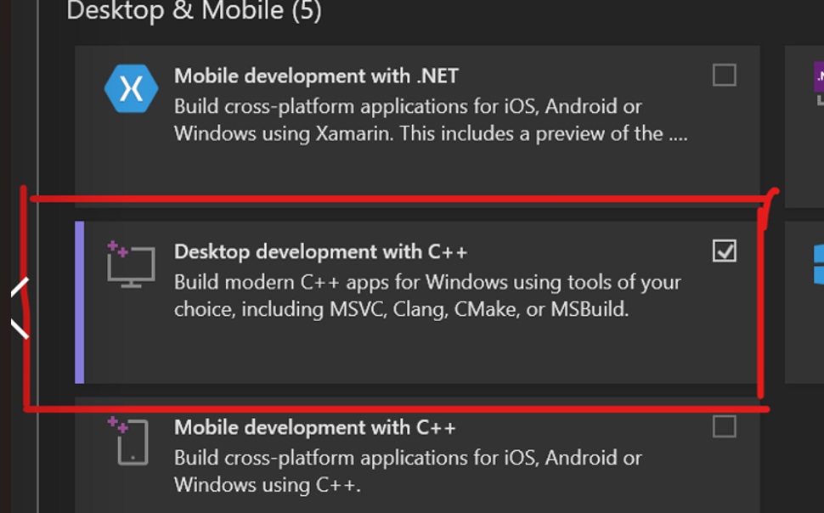Install the c++ compiler of the visual studio code community version. For that go to the visual studio code official website https://visualstudio.microsoft.com/visual-cpp-build-tools/ and download the visual studio code community version after that as you can see in the below image, select Desktop development with c++ while installing VS code.

### Step - 5 : Install cmake module.

After you have installed visual studio [Desktop development with c++] successfully, now go to your command prompt and use command : “pip install cmake”.

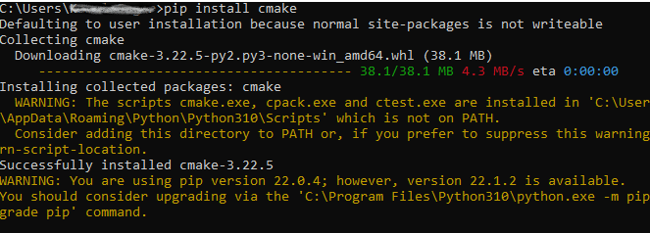

### Step - 6 : Install dlib library.

After you have installed cmake module successfully, go ahead and install the dlib library as shown in below image, using command : “pip install dlib”.

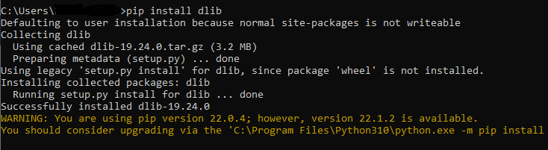

### Step - 7 : Open PyCharm and Open the project location

### Step - 8 : Open terminal and install the required libraries using the command

Command : “pip install -r requirements.txt”.

# **Once you have completed the steps, try running the code again. If it does not work, verify that each step was completed correctly before proceeding.**